**System Architecture**

**Definition:**  
Developing a decision support system and management tool designed to handle classroom scheduling on a university campus. Our system offers a solution for managing classroom scheduling at the City Campus, detecting conflicts during updates, and handling issues and requests in real-time while taking into account predefined constraints. It also provides a user-friendly interface.

**Data Structure and System Architecture:**  
The system is based on a **Relational Database Architecture**, where the data is organized in tables connected through **Primary Keys** and **Foreign Keys**.

**Why We Chose MySQL and Not MongoDB For example:**  
We selected MySQL because it allows executing complex queries easily, such as finding conflicts, identifying classroom availability, or generating reports in a relatively stable data structure. The data in the scheduling system is structured and requires relationships, which makes MySQL a better fit. As well as the system requires support for complex queries and analysis, where SQL excels. Ensuring data integrity is critical in a system like classroom scheduling, and MySQL is designed for such use cases while **MongoDB** can be used as an addition for other requirements (such as logs), but it is not suitable as the primary database.

**1. Classrooms Table**

| **Column Name** | **Data Type** | **Description** |
| --- | --- | --- |
| classroom_id | INT (PK) | Unique identifier for the classroom. |
| classroom_num | INT | Classroom number within the building. |
| floor_num | INT | Floor number within the building. |
| capacity | INT | Number of seats in the classroom. |
| is_remote_learning | BOOLEAN | Whether the classroom supports remote learning (Yes/No). |
| is_sheltered | BOOLEAN | Whether the classroom is a sheltered space (Yes/No). |
| building_id | INT (FK) | Unique identifier for the building. |

**2. Buildings Table**

| **Column Name** | **Data Type** | **Description** |
| --- | --- | --- |
| building_id | INT (PK) | Unique identifier for the building. |
| building_name | VARCHAR(50) | Name of the building. |
| rooms_num | VARCHAR(50) | Number of classrooms in the building. |
| capacity | INT | Capacity of the classrooms in the building. |
| remote_learning | BOOLEAN | Whether the classrooms support remote learning (Yes/No). |

**3. Boards Table**

| **Column Name** | **Data Type** | **Description** |
| --- | --- | --- |
| board_id | INT (PK) | Unique identifier for the board. |
| board_size | VARCHAR(20) | Size of the board. |
| classroom_id | INT (FK) | Unique identifier for the classroom. |

**4. Courses Table**

| **Column Name** | **Data Type** | **Description** |
| --- | --- | --- |
| course_id | INT (PK) | Unique identifier for the course. |
| course_name | VARCHAR(100) | Name of the course. |
| students_num | INT | Number of students enrolled in the course. |
| start_time | VARCHAR(50) | Weekly start time of the course. |
| end_time | VARCHAR(50) | Weekly end time of the course. |
| start_date | DATE | Start date of the course. |
| end_date | DATE | End date of the course. |
| course_type | VARCHAR(50) | Course type (e.g., Lecture, Practice, Lab, Seminar). |

**5. Lecturers Table**

| **Column Name** | **Data Type** | **Description** |
| --- | --- | --- |
| lecturer_id | INT (PK) | Unique identifier for the lecturer. |
| lecturer_name | VARCHAR(100) | Name of the lecturer. |
| role | VARCHAR(20) | Role of the lecturer (e.g., Lecturer, Assistant). |

**6. Schedules Table**

| **Column Name** | **Data Type** | **Description** |
| --- | --- | --- |
| schedule_id | INT (PK) | Unique identifier for the schedule. |
| classroom_id | INT (FK) | Classroom ID (linked to the Classrooms table). |
| course_id | INT (FK) | Course ID (linked to the Courses table). |
| schedule_datetime | DATETIME | Date and time of the schedule. |
| status | ENUM | Schedule status (Pending, Confirmed, Conflict). |
| created_at | DATETIME | Date and time the schedule was created. |
| updated_at | DATETIME | Date and time the schedule was last updated. |
| time_start | TIME | Start time of the schedule. |
| time_end | TIME | End time of the schedule. |

**7. Users Table**

(This table is not directly linked to other tables and is intended for system management and access control.)

| **Column Name** | **Data Type** | **Description** |
| --- | --- | --- |
| user_id | INT (PK) | Unique identifier for the user. |
| first_name | VARCHAR(100) | User's first name. |
| last_name | VARCHAR(100) | User's last name. |
| email | VARCHAR(100) | Email for login. |
| password | VARCHAR(100) | Login password. |
| role | ENUM | User role (e.g., Admin, Manager). |
| permissions | TEXT | User permissions for system access. |

**8. Constraints Table**

| **Column Name** | **Data Type** | **Description** |
| --- | --- | --- |
| constraint_id | INT (PK) | Unique identifier for the constraint. |
| course_id | INT (FK) | Course ID associated with the constraint. |
| classroom_id | INT (FK) | Classroom ID related to the constraint (if applicable). |
| constraint_type | VARCHAR(50) | Type of constraint (e.g., Capacity, Equipment). |
| constraint_detail | TEXT | Detailed description of the constraint. |

**Relations between tables:**

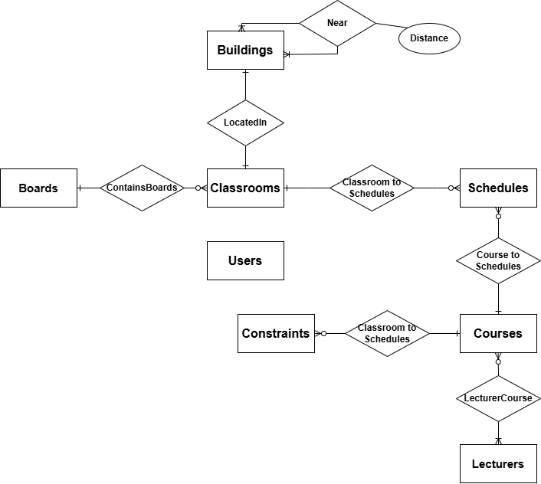

**Key Actions on the Client-Side (Front-End):**

* Form for Adding Schedules: Users can fill out a form to add new schedules to the system.
* Weekly Schedule Board View: Displays schedules organized by days and hours in a weekly format.
* Drag-and-Drop Feature for Courses with Instant Updates: Users can drag a course on the board from one slot to another (e.g., from 10:00 AM to 12:00 PM). As soon as the user changes the course's location on the board, the system sends a request to the server to update the new schedule in the database. The system performs immediate checks: Does this change create a conflict, such as overlapping courses or lack of available classrooms? If there is no issue, the update is saved. If a conflict arises, an alert is displayed.
  + - Successful Change: The course is shown in its new location on the board after the user confirms the change.
    - Failed Change: An immediate message is displayed, such as: “The course cannot be moved to this time due to a conflict(with more details).”
* Error Messages for Conflicts: Displays alerts when conflicts or issues are detected.
* Exporting Reports: Generate reports containing data like classroom usage, hours of operation, and statistical reports such as how much students are supposed to be in the campus in a given part of time.

**Key Actions on the Server-Side (Back-End):**

* API for Data Management:
  + POST: Add a classroom or schedule.
  + GET: Retrieve data (schedules, classrooms, schedule status).
  + PUT: Update existing data.
  + DELETE: Remove a classroom or schedule.
* Conflict/Duplication Detection Algorithm: Identifies issues such as a classroom assigned to more than one schedule at the same time.
* Automatic Scheduling Algorithm: Matches classrooms to courses based on constraints like room size, required equipment, and availability.
* Statistical Reports:
  + Calculates room utilization rates.
  + Provides availability insights by building.
  + Forecasts future workloads.

**Explanation of What Each Service Does:**

1. Uploading an Excel File and Saving Data in the Schedules Table:

* Client-Side:  
   The user uploads an Excel file containing scheduling data (classrooms, courses, dates, times, schedule duration, etc.).  
  The system displays a message indicating whether the file was successfully uploaded or if there were issues with its structure.
* Server-Side:
  + The server receives and processes the file.
  + Checks the file structure to ensure the columns match the required format (e.g., classroom_id, course_id, date, etc.).
  + Converts the file data into records and saves them in the Schedules table.
  + Each record from the file is stored as a separate row in the Schedules table.

2. Request to Change a Schedule:

* Client-Side:  
  The user is presented with an option to request a schedule change, such as modifying the time or classroom.  
  The user inputs their request along with constraints (e.g., a larger classroom or availability at a specific time).
* Server-Side:
  + The server checks the request against the entered constraints.
  + Identifies conflicts with existing schedules.
  + Checks the availability of classrooms that meet the requirements.
  + If the request is approved: The new schedule is saved in the Schedules table.
  + If the request is denied: A message is displayed to the user explaining the reason for the rejection.

3. Updating the System After Approving the Request:

* Client-Side: The system updates the schedule board and displays the updated information.
* Server-Side: The corresponding record in the Schedules table is updated with the new details.

4. Generating Reports:

* Client-Side:  
  The user selects the desired report type from the available options:
  + Classroom Schedule Report: Lists all schedules for a specific classroom, including dates and times.
  + Course Schedule Report: Lists all schedules for a specific course within a given period.
  + Classroom Utilization Statistics: Shows the amount of time each classroom is in use.

The user can define filters such as start and end dates, specific classrooms, or specific courses.

* Server-Side:
  + The server receives the request and performs queries on the database.
  + Processes the data and generates the report in the requested format.
* Client-Side: The user is given the option to download the report file or view the results in an interactive table.

**Tools and Technologies:**

Server-side Development:

* Visual Studio Code: Code editor for Python and JavaScript development.
* Python with Flask for creating a simple and flexible API.
* MySQL for database management.

Client-side Development:

* React for developing an interactive and modular user interface.
* HTML + CSS + JavaScript for designing and displaying the interface.
* FullCalendar: A JavaScript library for building an interactive calendar with drag-and-drop and update options.

**How it works:**

* The user enters data through a form on the client-side using React.
* The data is sent to the Flask server via an API.
* The server stores the data in the MySQL database.
* React retrieves and displays all the schedule entries.
* Project management and collaboration are done through GitHub.

**Process flow in the system:**

Process: Uploading an Excel file:

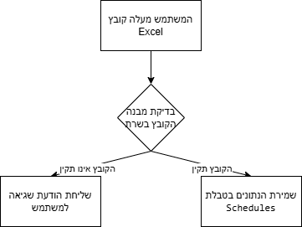

Process: Request for schedule change:

Process: Checking constraints and updating the system:

Process: Generating reports:

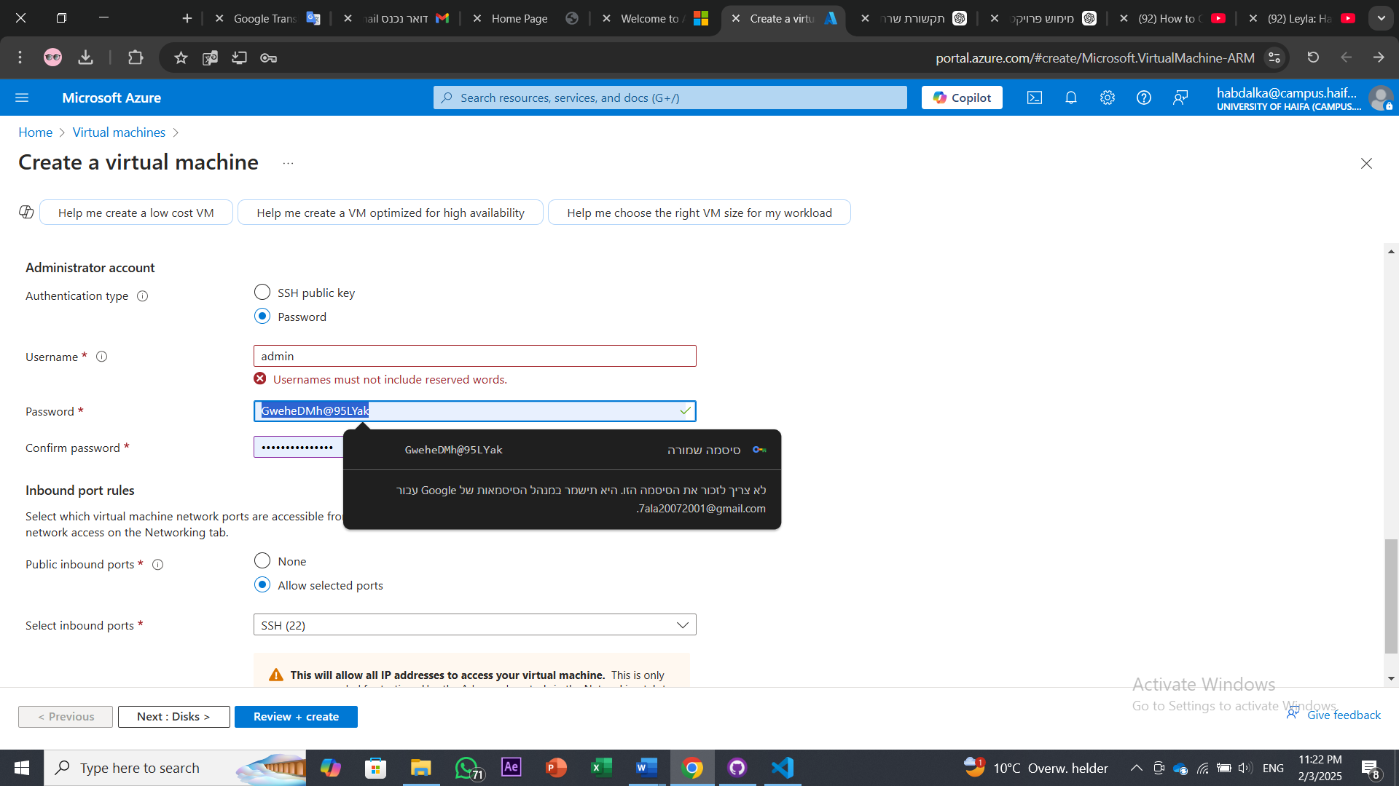

GweheDMh@95Lyak

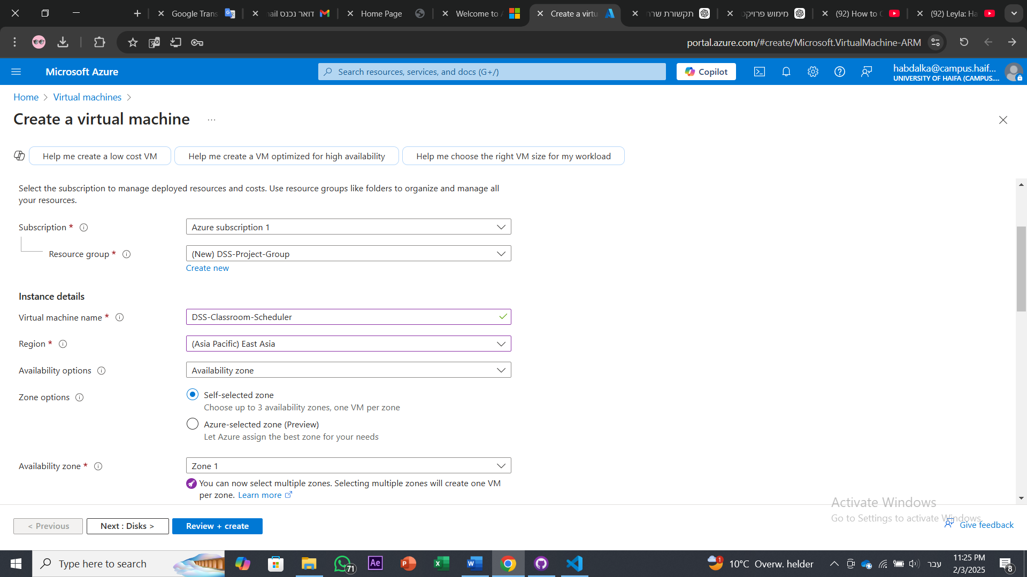

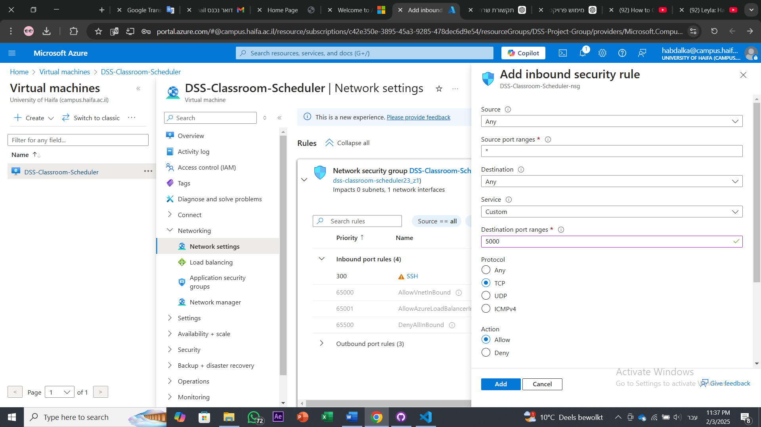

בהינתן את מבנה הפרויקט הזה עם הקוד הקיים הנתון תכתוב מה צריך לעדכן בקוד כדי לעשות את זה ( תכתוב את הקוד אחרי העדכון בלי למחוק קוד מהקיים ) ובנוסף אני רוצה שהעלאת הקובץ הזו תתבצע פעם אחת ( אם המשתמש נכנס ורוצה להעלאת קובץ חדש ויש קובץ קיים שהועלה למערכת ונשמר במסד הנתונים המערכת לא תאפשר לו להעלות את הקובץ רק אם הוא ילחוץ על מחיקת הקובץ הישן ואם הוא מחק את הקובץ הישן הנתונים ימחקו ממסד הנתונים ויכנסו הנתונים החדשים של הקובץ החדש שיעלה אותו אחרי שימחוק את נתוני הקובץ הישן ) תעשה את העדכונים האלו בהתבסס על קובץ Project Architecture - DSS for Classroom Scheduling

תכתוב קוד לשינוי שיבוץ. המשתמש נכנב למסך request_schedule בוחר שיבוץ אחד מהשיבוצים הנמצאים בטבלת schedules. כאשר הוא בוחר את השיבוץ, נתוני השיבוץ יהיו מוצגים במסך עם אפשרות לעדכון אותם. הנתונים מתעדכנים במסד הנתונים בכל הטבלאות הקשורים להם. תכתוב את קוד הדרוש בהתבסס על מבנה הפרויקט שלי ובלי למחוק משהוא מהקוד הקיים

cd C:\Users\hp\Documents\GitHub\FinalProject_DSS-for-Classroom-Scheduling\DSSClassroomScheduling\Backend

set FLASK_APP=app.py

flask run --host=0.0.0.0 --port=5000

telmenal hdash

C:\Users\hp\Desktop\ngrok.exe http 5000

C:\Users\hp\Desktop\ngrok.exe http 5000